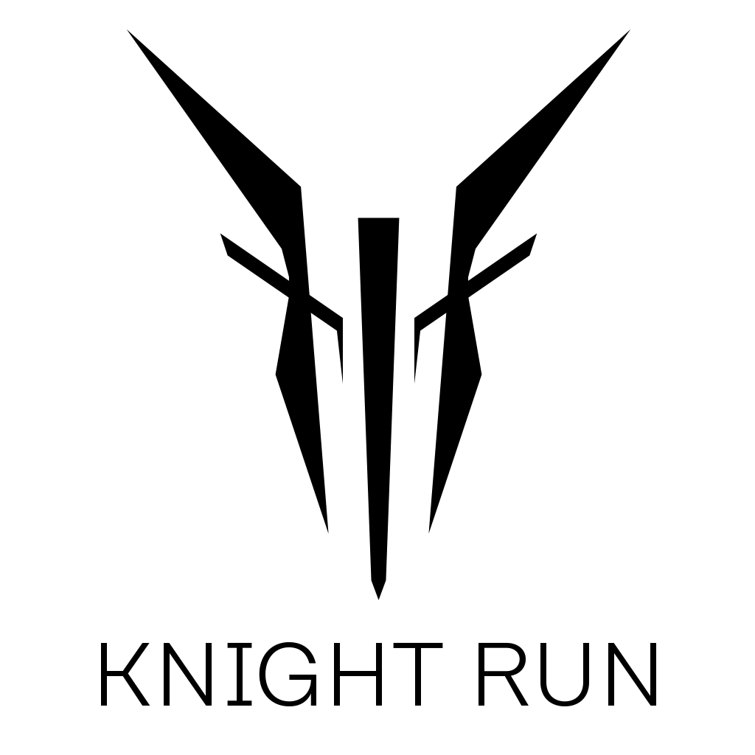

Creative Brief

Content

Overview

Story

World

Mechanics

Overview

Knight Run is a Third-Person Action Adventure game inspired by the LINE Webtoon series by the same name.

Story

Knight Run tells the story of Anne and Pray Myer, two exceptional Knights who work with the Central Knights.

Knights are humans who have beyond human capabilities, special humans who can go up against the ABs who threaten to eliminate humanity. Knights are equipped with AB swords, the only weapons capable of wounding ABs.

It is an endless fight between Humans and ABs, as the ABs has already had their 42nd Queen invade and corrupt a planet.

World

Knight Run tells its story and places its setting in the far future, where space travel has become possible. Humans colonize planets far and wide and setup communities to try and thrive there.

As each colony is small, they aren’t very technologically advanced, except for a few planets where Knights have setup bases. The world we will be focusing on is called Arin, where Anne and Pray live.

Mechanics

* Hack and Slash Precision Combat
* Anachronic Story Telling

Knight Run boasts two mechanics, a hack-and-slash precision combat style. This means fast paced combos with equally fast reaction times and counters.

References are drawn from games such as For Honor, in its defensive style and Nier: Automata, for its combat fluidity.

The other mechanic is its story-telling method. Knight Run borrows heavily on the way Beyond: Two Souls tells its story. This method also draws on the comic that inspired this game as the author used a similar method to convey the story and build stronger reader and character relationships.